SpanningTree.py file contain python code which will give you the Spanning Tree of the respective Connected Graph.

SpanningTree.py takes a csv file that contain the Graphs and with their number of nodes and edges respectively.

There are some rules for csv file:

1. The '#' works as a separator to separate Graphs.

2. Just below the '#' cell the number represent the number of nodes in that Graph.

3. Below that cell there is bunch of pair or cells that represents edges.

4. '!' is use as End Of File.

In this Folder 'Spanning Tree' there is a sample csv file named 'SpanningTreeDataset' or you can make your own.

Load that csv file (or csv file created by you) and 'SpanningTree.py' will output the respective Spanning Tree

Our Graphs in our csv file looks Like:

Graph 1:

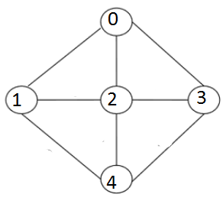

Graph 2:

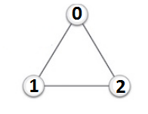

Graph 3:

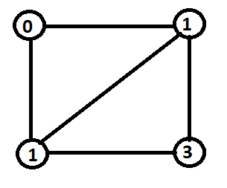

Graph 4:

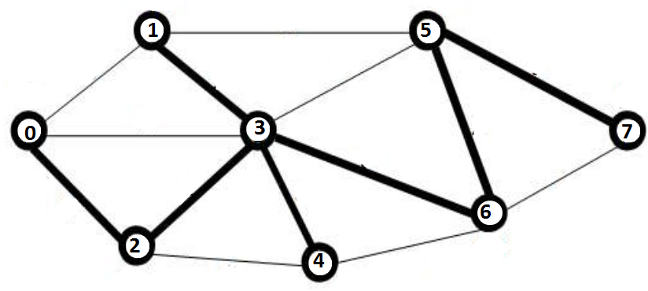

Graph 5:

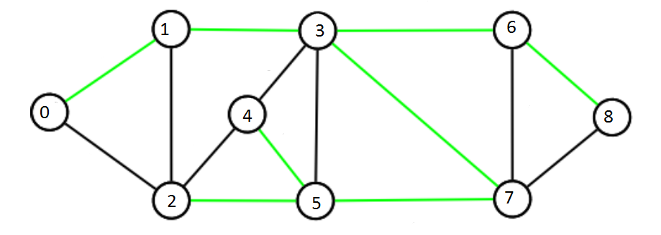

Graph 6:

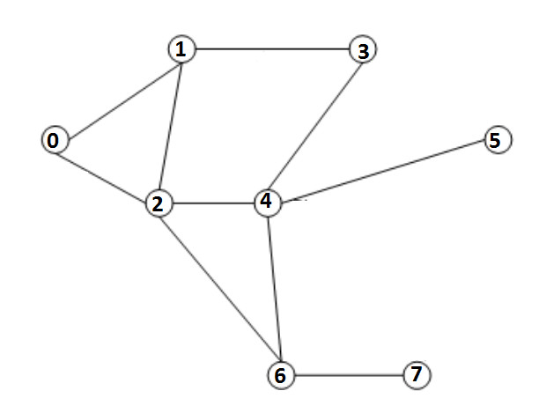

Graph 7:

